*(Car Constructing)* In a car manufacturing company, each car is putting together by a team consist of 4 workers, and the parts needed to be constructed of a car is divided into different categories: wheel, engine, car body, lights. There are 100 pieces of these parts in each categories, total 400 parts need to be construct by workers. Each worker only can construct one category of the car. The constructing time for each worker of each car pieces categories are shown in the table. To minimize the constructing time, which worker should construct which part of the car?

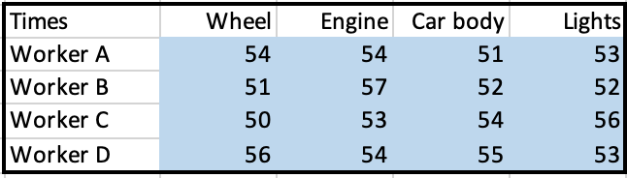

*Discussion:*

Our objective in the problem is to minimize the total time. Time taken by each worker to finish 100 pieces for each car part to be constructed is given as out input. Our model should decide which worker needs to be picked for each car constructing category.

Mathematical Model:

*Parameters (Inputs):*

$$i ϵ 1,2,3,4 \left( i: Index for car part category\right)$$

$$j ϵ 1,2,3..8 \left( j: Index for workers\right)$$

$$A_{ij} : Time taken by worker j to construct 100 pieces of car part i$$

*Decision Variables:*

$$x_{ij} :Decision whether to pick worker j to construct car part i$$

*Objective:*

$$Minimize total time=\sum_{j=1}^{4}{\sum_{i=1}^{4}{\left(x_{ij}*A_{ij}\right)}}$$

*Constraints:*

$x_{ij }ϵ \{0,1\}$ (1) *Binary constraint*

$\sum_{i=1}^{4}{x_{ij}}=1 ; for j ϵ\left\{1,2,3,4\right\}$ (2)*Number of car part category for each worker constraint*

$\sum_{j=1}^{4}{x_{ij}}=1 ; for i ϵ\left\{1,2,3,4\right\}$ (3) *Should cover all the car part categories*

Constraint 2 will make sure that a worker can go for only one part of car part constructing process. Constraint 3 makes sure that workers were assigned to all the part to complete the car construct.

*Excel Implementation:* Please find the attached spreadsheet for solution.

